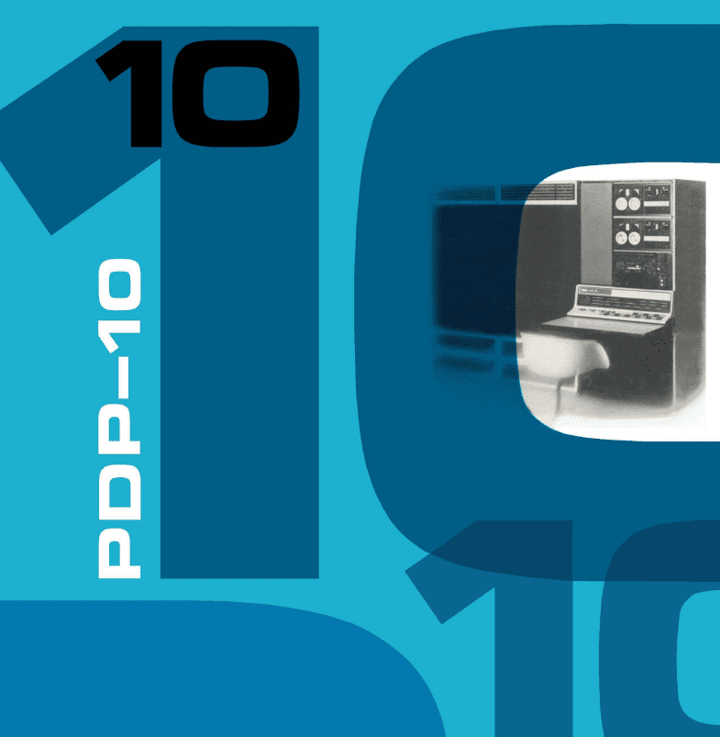**PIDP-10**

**SYSTEMS USER’S GUIDE**

EARLY DRAFT VERSION 2024.04.23

THIS IS WORK-IN-PROGRESS

but will be updated weekly from here on

**Table of Contents**

Introduction 3

Credit where credit is due 3

Quick start 5

The PiDP-10 concept 6

Using the PiDP-10 7

Installing 7

Starting up 7

Getting into ITS 10

ITS walkthrough: Light Entertainment on the Mainframe 11

Introduction 11

Starting the ITS Walkthrough 11

Logging in on the Knight TV 14

Hacking spacewar and using tvwar 15

Adding a VT-52 terminal session, some Lisp therapy 17

Multiple jobs 19

The Ultimate 1970s AI demo: SHRDLU 20

Headless: remote Knight TV sessions 21

Multi-Player Maze War 22

Gosper’s Game of Life: the original 23

Shutting down gracefully 24

Bubble Universe - Democoding on the Color Scope 24

A first look at TOPS-10 27

Front panel operations – a primer 29

The basics 29

Program Control 30

Networking on the PDP-10 32

File exchange between ITS and Linux 32

Terminal sessions over Chaosnet: supdup 32

Chaosnet 32

Future Networking sections 32

Further reading 33

# Introduction

Thank you for bringing a 1960s mainframe into the living room! The purpose of the PiDP-10 project is to keep hands-on knowledge of the PDP-10 alive, and to help build a new user community to the only personable mainframe in history.

This manual is kept short, as many of the PiDP-10 resources are online. So for any in-depth information, links are provided; and the manual focuses on being a quick get-to-know guide for the machine. To get you started.

Much attention is given to the **ITS** operating system and all the surrounding MIT AI Lab hardware. The next page shows you just how much hardware there is to play with, inside the PiDP-10.

But equally important, DEC’s own **TOPS-10** operating system is fully supported too, it is the other boot option for the PiDP-10. We hope that there will be a lively new community around TOPS-10 as well.

The PiDP-10 is a model KA10. But separate simulators are added for other PDP-10 models (the KI, KL, KS) and thus, **TOPS-20** can also be run on the PiDP-10. The front panel will not be entirely complete for these other PDP-10 systems, but in fact, most of them did not even have a front panel. So we’d argue the PiDP-10 is not at a disadvantage.

## Credit where credit is due

The PiDP-10 wraps the work of many people into its physical front panel.

@rcornwell wrote the PDP-10 KA10 simulator (the Engine), @larsbrinkhoff did the heavy lifting on the ITS Reconstruction Project, @aap added the PDP-6, Knight TV and many other elements.

But they built on a community of dozens, going back a long time. Ken Harrenstein's emulator in 1992 was the start, and he did the first work on a Personal ITS distribution. In the early 2000's ITS was also running on Bob Supnik's SIMH.

Huge strides were made by @rcornwell adding ITS support to his KA10 emulator. Work with @larsbrinkhoff during fall 2017 resulted in ultimately booting this very accurate KA10 simulator successfully on January 8, 2018. Much of the following AI lab emulation followed from of this.

@eswenson1 and @atsampson did almost everything related to Maclisp, Macsyma, Muddle, and Zork. @bictorv is the cherished champion of Chaosnet. Without the effort of @lisper et al we wouldn't have the wealth of backup data to draw from. And ITS would only have been a whisper of a ghost of its former grandeur. And of course, ITS preservation started already in the 80s with @bawden and many others, many of whom are true heroes of computer history.



# Quick start

**Before powering up the Pi, set the data switches to choose a PDP-10 boot configuration**

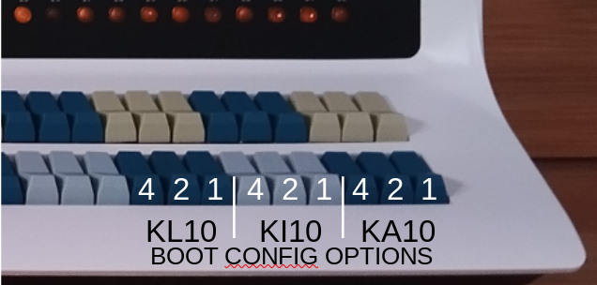Currently available boot options:

----------------------------------------

001 ITS KA10

002 TOPS-10 KA10

200 TOPS-20 KL10

----------------------------------------

Any other number on the data switches will start Blinky – a little blinkenlights demo program.

*If you are not yet familiar with octal front panels: these 9 switches form a 3 digit octal number. So 200 means setting the ‘2’ switch on the left-hand group of three dark blue switches; 070 would mean you set all three switches on the middle group of three light blue switches (4+2+1=7).*

**The PDP-10 simulator is started in the background when you log in to the Pi.**

**If you selected ITS**: the ITS boot configuration keeps things very authentic. You have to press STOP, then READ IN on the front panel to get the system booted off the virtual paper tape bootstrap. The other boot configurations will boot straight to input on the console port. This is only when you start the PiDP-10 through the data switches on the front panel, not if you start it using pdpcontrol start x

**pdpcontrol: from the Linux command line, starts, stops, restarts the PDP-10.**

pdpcontrol stop - halts the PDP-10 simulator

pdpcontrol start - starts with the boot option set at the data switches

pdpcontrol start x - starts with the bootscript x, ignoring the data switch settings

(used if you have a Naked Pi without PiDP-10 hardware!)

**pdp: when the PDP-10 is running, manages various hardware.**

pdp con - starts a noisy Teletype simulator on the console (only on HDMI display)

pdp telcon - starts a quiet telnet session on the console instead (anywhere)

pdp vt52 - starts a VT52 terminal (only on HDMI display)

pdp tvcon - starts a Knight TV terminal (only on HDMI display)

pdp ? - see all the other terminal and display options

pdp view - starts an all-in-one overview

pdp - brings you into the simh simulator itself

CTRL-E: halts the simulator and brings you into the simh command line

continue: continues the simulator

CTRL-A d: leaves the simh smulator to run in the background again

**Using a laptop or remote connection to get a terminal on the PiDP-10**

There is a binaries-for-X86-64.tar.gz file in /opt/pidp10/bin that you can copy to a Linux desktop or laptop. It contains the same terminal simulation programs that the pdp command runs locally on the Pi, compiled for regular Intel Linux. For example, on a Linux laptop, you can get a Knight TV terminal on the PiDP-10 by typing ./tvcon -2BS pidp10.local , assuming that your PiDP-10 is called pidp10 and is on the same local network. Look into the /opt/pidp10/bin/pdp.sh script to see calling details.

# The PiDP-10 concept

**The goal was to set up the PiDP-10 such that it is:**

* **Dual-hearted**. The real CPU offers you a normal Pi, and a ‘soft CPU’ a PDP-10. We like the PDP-10 and the Raspberry Pi, so the PiDP-10 is both *at the same time*.
* **Configurable**. The PDP-10 can be used *either* asan ‘all-in-one’ on the Pi’s HDMI monitor (easy to start with, everything is on your screen), *or* (more authentic) ‘headless’. In the latter approach, you connect from remote terminals. The HDMI display is now only used for the type 340 graphics display.   
  The remote terminals can be real serial terminals (or Teletypes), terminal simulator programs run on a laptop, or plain telnet sessions. In the headless setup, the simulation can be controlled from a ssh command line, through the pdp and pdpcontrol commands.

**It helps to know how the PiDP-10 actually works:**

1. The entire package is located in /opt/pidp10.   
   bin/ contains all binaries, systems/ contains disk images and boot scripts for each boot option, install/ contains the install script, src/ the source code.
2. When you power up the Pi, the line pdpcontrol start in ~/.profile ensures the PDP-10 is started up. Look inside that script: opt/pidp10/bin/pdpcontrol.sh
3. The scansw10 program is called from pdpcontrol to read the front panel data switches[1]. The bootscript corresponding to the number read from the switches is then looked up in the text file systems/selections, and passed on to the emulator (simh) which is started next. Simh uses it to configure itself for that OS.
   * You can add your own customised boot options by adding subdirectories to the text file systems/selection. The subdirectory must contain a boot.pidp (used for the PiDP) and boot.pi (used for Pi’s without PiDP-10 hardware).
4. Simh is run inside a screen virtual terminal, which stays in the background. You can call it up whenever you have a need to use it (which might be never). Just run the command pdp .
5. The chosen simh bootscript configures the simulated hardware. It assigns disk image files to simulated disk drives, and simulated serial ports are brought out as telnet ports on the Pi[2]. Have a look at /opt*/*pidp10/systems/its/boot.pidp

At this stage, then, you have a simulated PDP-10 running in a hidden virtual ‘screen’ terminal, listening on telnet ports, waiting for devices such as terminals to be ‘plugged in’.

1. What you connect to the telnet ‘serial’ ports is up to you. It could be the standard Linux telnet program run on the Pi itself, or a telnet session from another computer. It could also be a nice graphical emulator of a VT 52 (run on the Pi, or on a laptop). Whatever it is, it connects through the telnet port[3].

# Using the PiDP-10

## Installing

Prepare a regular Raspberry Pi SD card using the Raspberry Pi Imager program. Make sure you pick the 64 bit version of the OS. At the time of writing, the latest OS version was ‘Bookworm’; older versions of the OS will not work.

Boot up the Pi, and get Wifi going. Now, do:

cd /opt

sudo git clone https://github.com/obsolescence/pip10

opt/pidp10/install/install.sh

The install script will ask you a lot of questions. Just say ‘yes’ to all of them, although you might want to skip the ‘install source code’ and ‘install source code dependencies’ sections; they take a lot of time and disk space.

## Starting up

Set the bottom row of switches to select the operating system that you want to boot:

* Setting SR 35 (rightmost switch, bottom row) will prepare to boot ITS;
* Setting SR 34 will boot TOPS-10;
* Setting no switches (or not having a PiDP-10 front panel!) will run the Blinky demo

**Reboot**. The front panel will light up when you log in again on your Pi. The tell-tale sign that you have chosen the ITS boot option is a quick running lights effect on the bottom row of lights on the front panel.

If you actually don’t have a PiDP-10 front panel plugged into the Pi: type ‘pdpcontrol stop’, wait a few seconds, type ‘pdpcontrol start 1’. The 1 tells the simulator it should not read the switch settings but just boot option 1, ITS.

The following assumes you run a Pi with the GUI on a HDMI monitor. None of that is necessary, but this is the Quick Start after all:

* Double-click the icon on the top left of the Pi’s GUI desktop, choose ‘Execute’  
  (alternatively, type ‘pdp view’ on the Pi’s command line).

The PDP View window will pop up. You can open and close it as you wish, it will not interfere with the running PDP-10 system. It is **not** the PDP-10 simulator. Just a convenient view into it.

To explain the PDP View window :

* 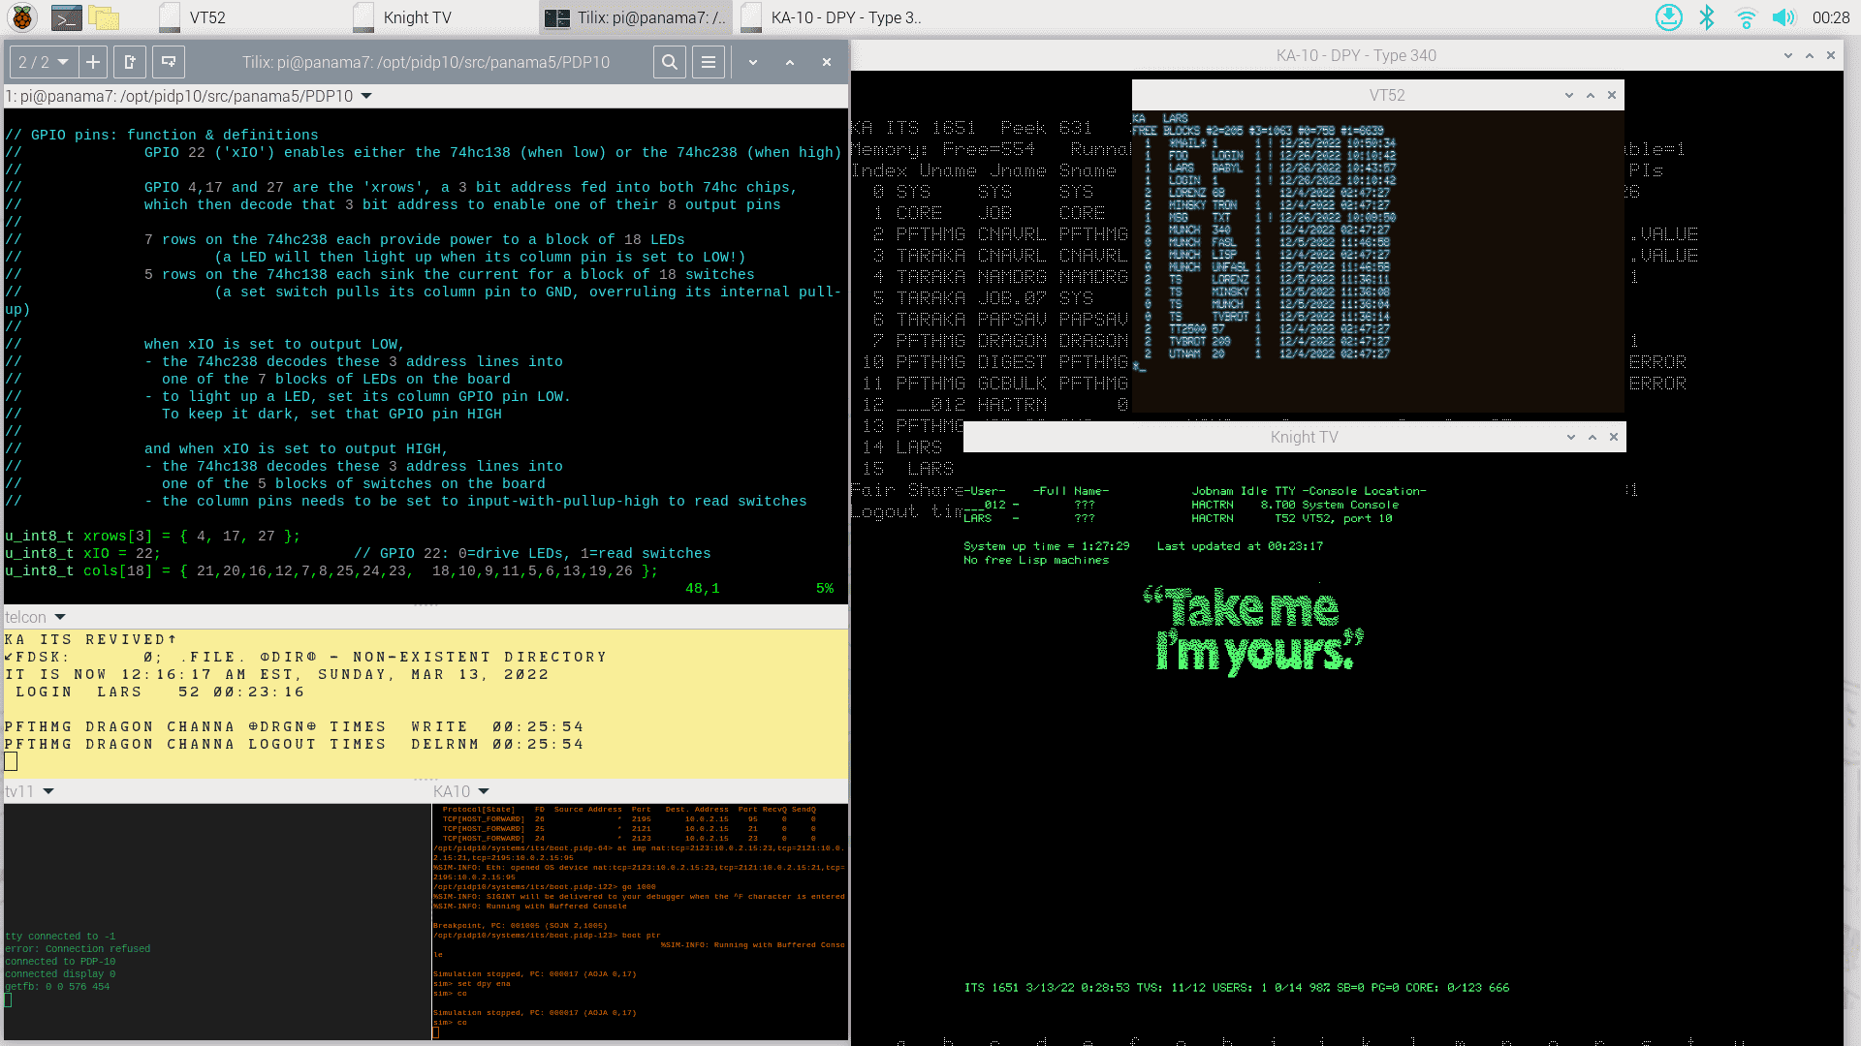the **yellow** window is the Teletype on PDP-10’s console port.   
    
  Required during the boot process, and it will regularly print out system status messages.

* at the **bottom right** is a view on the PDP-10 simulator.   
    
  Useful to check its status, but also, CTRL-E will bring you into the simh command line, which is very powerful, including PDP-10 debugging and a mini-assembler/ disassembler.
* at the **bottom left** is a view on the PDP-11 simulator running the Knight TV terminals. Not very useful, but just to check it is OK and (later on) if any Knight TV terminals are active.

**The large window at the top** is simply a generic Linux command line, to use as you see fit.

Three obvious uses for PDP-10 purposes:  
  
- **PDP**: Controls extra hardware. Type ‘pdp ?’ to see the various options. For example, ‘pdp vt52’ launches an on-screen VT-52 terminal simulator; ‘pdp tvcon’ a Knight TV terminal.  
  
- **PDPCONTROL**: Control the PDP-10 itself. Principally, ‘pdpcontrol stop’ and ‘pdpcontrol start’. One special function: no matter what the front panel switches are set to, ‘pdpcontrol start 1’ boots ITS.  
  
- **Use as a PDP-10 terminal**. Type ‘telnet localhost 10018’ to use the top window for a simple login to the ITS system. It’s just like any of the ‘pdp’ terminal options, it gets you a terminal into ITS. But in this case, it’s a plain-vanilla telnet login. Once logged in to ITS (see below) use ‘:tctype vt’ to tell ITS to use the right terminal control codes.

pdp view is *just* a handy widget when you use the Pi’s HDMI monitor. If you run the PiDP-10 headless, you can still use it through VNC.

But PDP View does nothing that the pdp and pdpcontrol commands won’t do for you on the command line. For instance, ‘pdp telcon’ will get you access to the Teletype.

## Getting into ITS

For this Quick Overview, we will assume that you installed the PiDP-10 software, set switch SR35, to boot up the ITS operating system, and you have opened PDP View.

At first, you will see a quick ‘running lights’ effect on the bottom row of front panel lights. This is just a tiny program that the PDP-10 is running, waiting for you to do more meaningful things.

Press the STOP switch to halt the PDP-10, and then the READ IN switch. This triggers a circuit in the PDP-10 to start reading a paper tape, and then run the last instruction found on that tape. It’s the standard way to bring up a PDP-10.

You will see the message ‘DSKDMP’ appear on the yellow Teletype window. DSKDMP is the program loaded from the paper tape. It is waiting for your input.

Type ‘ITS<return><esc>G’ and DSKDMP will comply by booting ITS off disk. Some messages pass by, including ‘TV11 IS DOWN’, then, a bit later ‘TV11 IS UP’. This means that the PDP-11 that supports the Knight TV terminals is connected.

From here, you are free to use ITS.

* From the Teletype: Press CTRL-Z to get to the command line.
* Use a Knight TV Terminal: run ‘pdp tvcon’ from the Linux command line (in the upper window of PDP View, for instance). A Knight TV terminal will appear on screen. Hit F1 to get to the command line. F1 on a Knight TV terminal is the same as CTRL-Z on any other terminal: the ‘CALL’ signal to wake up ITS for this terminal.
* Use another terminal type: on the Linux command line, do ‘pdp ?’ to see the available terminals. ‘pdp vt52’ will get you a vt52 terminal window, for instance. Again, press CTRL-Z to get to the command line.
* From the top window of the PDP View (above the yellow Teletype): type ‘telnet localhost 10018’. Again, CTRL-Z to get to the ITS terminal.

For this Quick Overview, we keep it at the above possibilities. But there are many others:

* You can also run the Knight TV terminal emulator (tvcon) on a laptop and log in from there. In opt/pidp10/bin, you will find a tar file with binaries that run on X86/64 Linux. The command is tvcon -2BS pidp10.local (assuming that you chose pidp10 to be the name of your Pi).
* You can also simply telnet into the Pi from anywhere, for instance ‘telnet pidp10 10018’. You can also get the Teletype from a remote machine: ‘telnet pidp10 1025’. (This assumes your Pi is named pidp10, obviously, and that you have logged out of any other telnet session using the port – like the yellow Teletype window in PDP View.
* You can use real serial terminals over a serial port. Etc, etc.

See the section ‘An ITS walkthrough: Light Entertainment on the Mainframe’ for next steps.

# ITS walkthrough: Light Entertainment on the Mainframe

## Introduction

This section is simply a walk-through demonstration of some fun or interesting programs on ITS to get you familiarised with the system. All we want to do is give a first flavour. Also, we use the Pi’s HDMI monitor as our main terminal. But keep in mind that is not necessary – in fact, most of the time, you’d use a laptop with terminal emulator to connect to the PiDP-10. We’ll briefly explain that too.

For more in-depth information:

* A modern ITS manual is progressing here: https://github.com/larsbrinkhoff/its-manual/wiki
* Another useful reference: <https://its.victor.se/wiki/start>
* The online help inside ITS. Try :HELP, :INFO, and the documents in the .INFO. directory.

## Starting the ITS Walkthrough

Set the PiDP-10 to boot up with ITS (by setting the rightmost of the 36 data switches), and power up. You will see the front panel light up and see the Pi’s desktop:

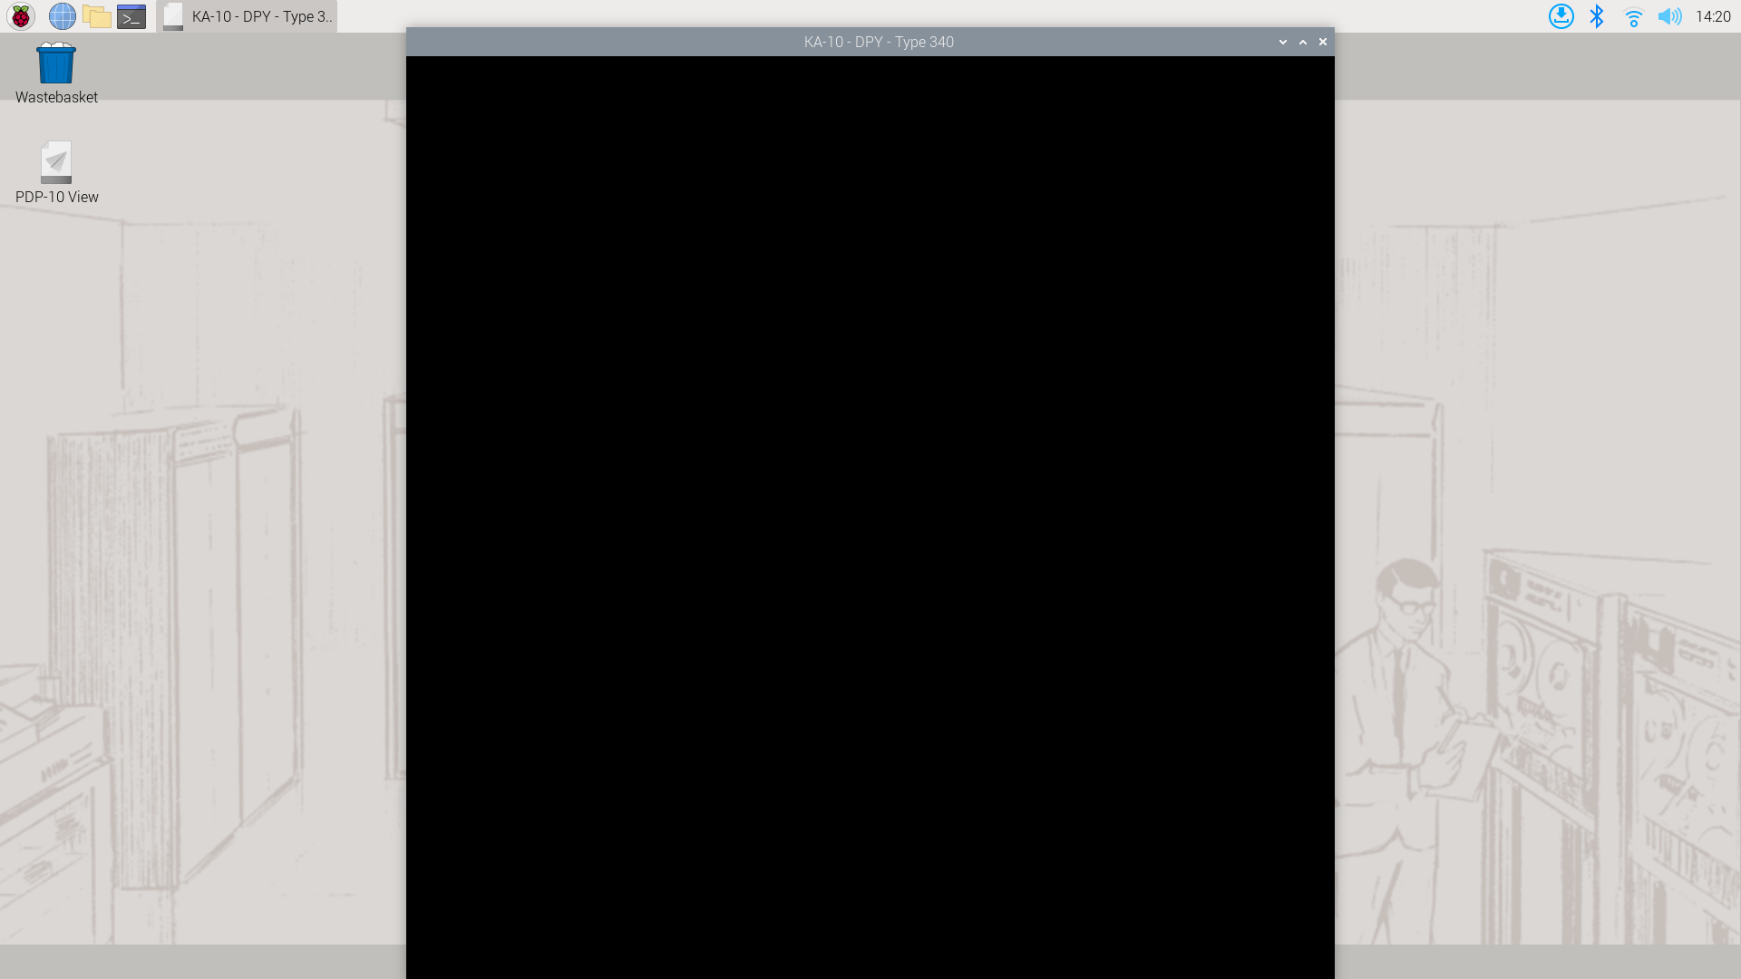

April 2024: Possible bug sometimes hinders the type340 display window to open, the first time after the Pi boots. If you see the desktop but not the KA-10 DPY window, open up a Pi terminal and type ‘pdpcontrol stop’, wait a few seconds, and type ‘pdpcontrol start’. Apologies, will be fixed soon.

Double-click to execute the PDP-10 View icon on the desktop. This gives you an all-in-one view of the PiDP-10:

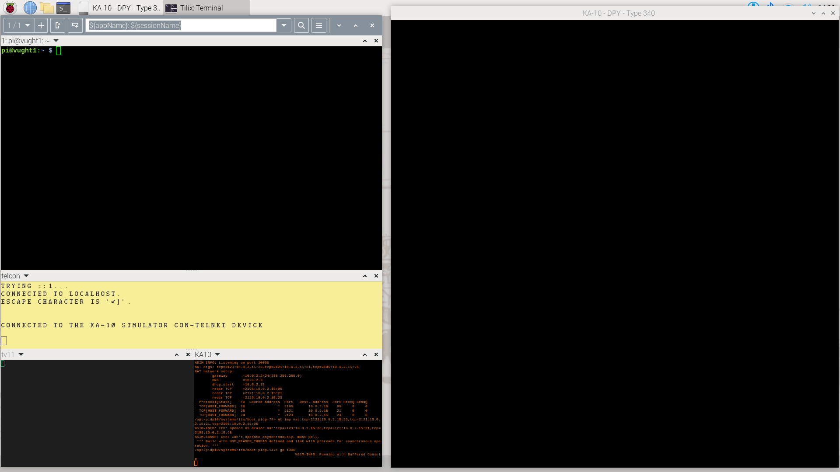

The yellow terminal is the simulated Teletype on the PDP-10’s console port. We moved the type340 graphics display to the right. The PDP-10 is running on air at the moment, and to bring up the system: press the STOP switch, and then the READ IN switch. The latter triggers a PDP-10 to read DSKDMP from paper tape and starts running it.

I. If you run on a ‘Naked Pi’, i.e. without the PiDP-10 front panel, no need to press any switches (as you will not have any!).

II. Note that the PDP View window is just a handy collection of terminal windows. It’s not really part of the PDP-10 simulation, you can do everything on just a regular command line as well. For instance, when you run a ‘headless’ PiDP-10. As mentioned earlier, pdp and pdpcontrol are the real PiDP-10 commands you need.

III. It gets old rather quickly, but for demonstration purposes you could also have used the ‘real time’ Teletype simulator (real time, meaning, as slow and noisy as the original) instead of this all-in one PDP View. Instead of starting pdp view, on the Linux command line, type pdp con and that will be used as the PDP-10’s console instead of PDP View. And on a headless PiDP-10 (on a ssh connection for instance), you should use pdp telcon instead. Or just telnet localhost 1025. You can switch between these Teletype options mid-flight, as long as you leave the telnet connection orderly (Ctrl-], then quit)

You will see DSKDMP report itself on the Teletype:

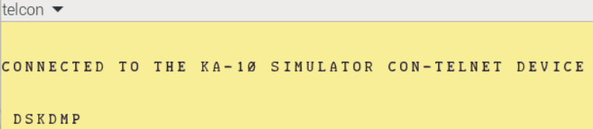

Type ITS <esc> G to boot into ITS, and you’ll arrive at this stage:

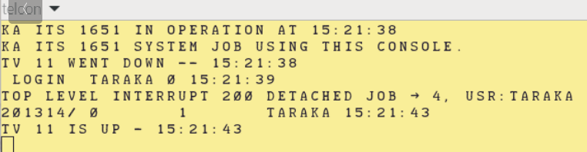

You can press Ctrl-Z to sign in to ITS from the Teletype. From here, the Teletype is just like any other terminal on ITS, with the exception that ITS prints out regular system state updates on it as well.

But Teletypes are no fun. Instead, on the Linux command line, type pdp tvcon, and a a Knight TV terminal pops up. We’ll start off pretending you are an MIT student, for them this was the default way of getting access to the PDP-10.

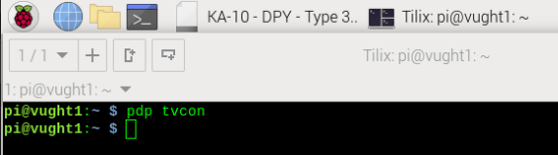

The Knight TV terminals consisted of a TV tube and a rather nice custom keyboard; 16 of them were connected to a PDP-11, which acted as the terminal multiplexer, sharing memory with the PDP-10. Note that on the Teletype, you saw a message TV-11 is up, to confirm that the PDP-11 is indeed up and running. The status of the TV-11 is shown at the bottom left of PDP View.

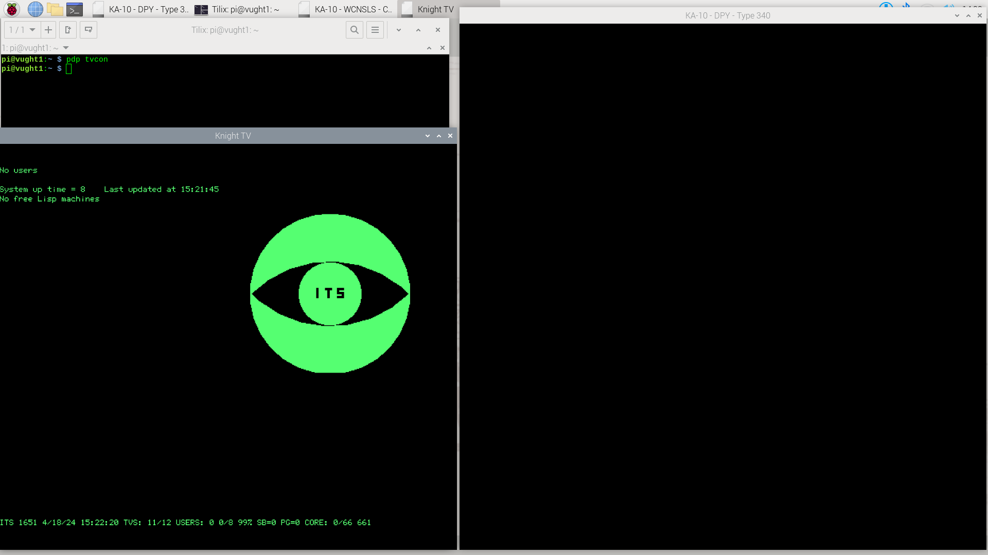

Knight TVs were amazingly powerful terminals – not only could they do graphics, but students could view other’s displays, or even take over control from their own keyboards. Keep in mind that the things below were done in 1972, long before such features were available anywhere else.

## Logging in on the Knight TV

Hit F1 to get into ITS. F1 on the Knight TV is the same as CTRL-Z on the Teletype console and on all terminals. It’s just that the Knight keyboard had a dedicated ‘CALL’ key for this.

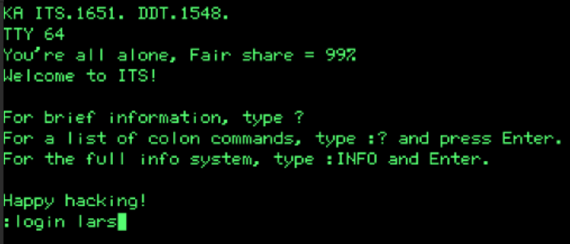

ITS does not do security; passwords and access restrictions just stand in the way of hackability. But it was polite to login. The link below helps you to set up your own account, with mail and your own work directory. But for now, you’ve stolen the lars account to use... Type

:login lars

Follow the instructions on the ITS Wiki to set up your own user account, with your own directory, mail, etc.: (<https://github.com/larsbrinkhoff/its-manual/wiki/Adding-a-new-ITS-user>)

You are now in HACTRN, the ITS debugger which (interestingly) doubles as the shell. Press Ctrl-F to list the directory of this user. ITS generally has long-form commands (:login, :listf) and alt-mode shortcuts (<esc>u, Ctrl-F). Using the long-form versions is generally considered to be for Turists and Lusers… noobs.

It is also very Turisty, even Luserish, to say <esc>. The proper ITS term is **Altmode**. Altmode is Esc. And the regular Alt key on your keyboard does not play a role in ITS life. We stick to saying <esc> here, because it is just a quick walk-through. No point adding confusion.

Run the Minskytron demonstration program, by typing :minsky . Although the very fine dots are not clearly visible in the printed screenshot below, the type340 display will come alive. Play with setting the data switches to influence the Minskytron patterns. The source code is in the same directory, and this might be a nice basis for building your own display demo hack some day.

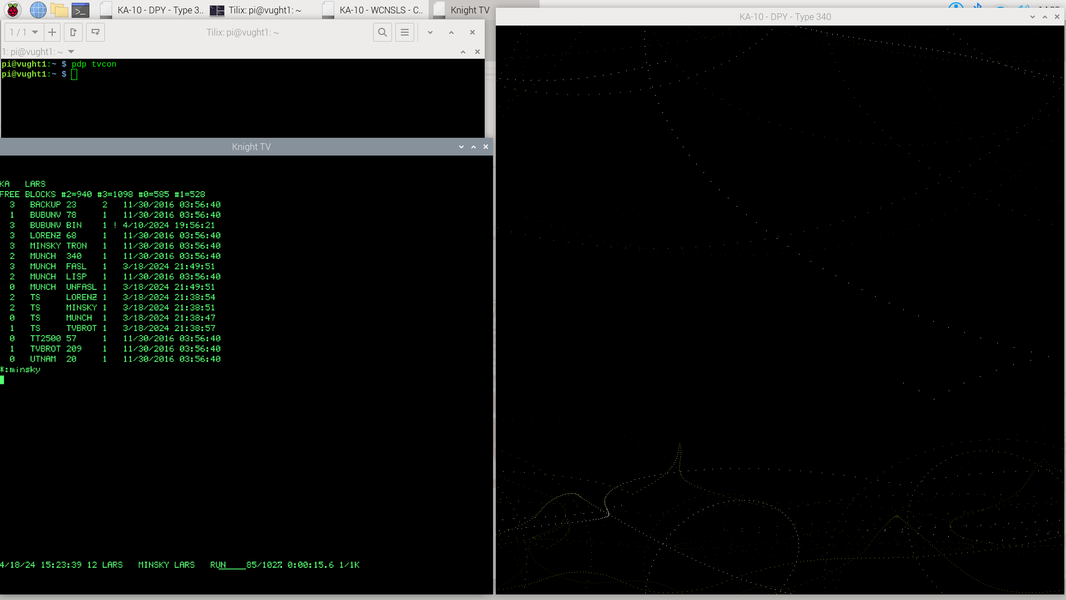

Abort Minskytron using F1 (or Ctrl-Z on any terminal other than the Knight TV), which drops you into HACTRN, the ITS debugger/command line interpreter again. The screen shot does not show it, but it would be good form to type :KILL so as to end the Minskytron job, and not just leave it suspended. It is often useful to clear the screen by pressing Ctrl-L.

## Hacking spacewar and using tvwar

Now, change to the games directory by entering :cwd games

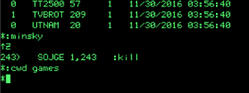

List the games directory by typing Ctrl-F, just to get an idea of what is there. Filenames in ITS consist of two 6-character fields; if the first field contains ‘TS’ (for timesharing), that denotes an executable which runs under ITS. One of them is TS SPCWAR.

So type :spcwar to start this vintage (because, first ever) video game in its PDP-10 incarnation:

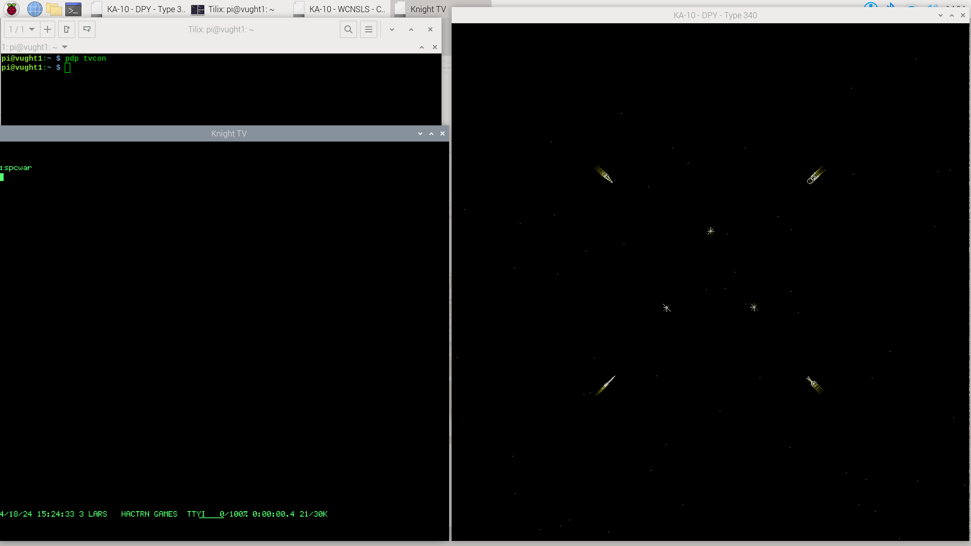

You will need USB joysticks to actually play the game; but even without, you get a pretty good impression of it. By default, PDP-10 spacewar starts up in the fancy version with three suns and four spaceships:

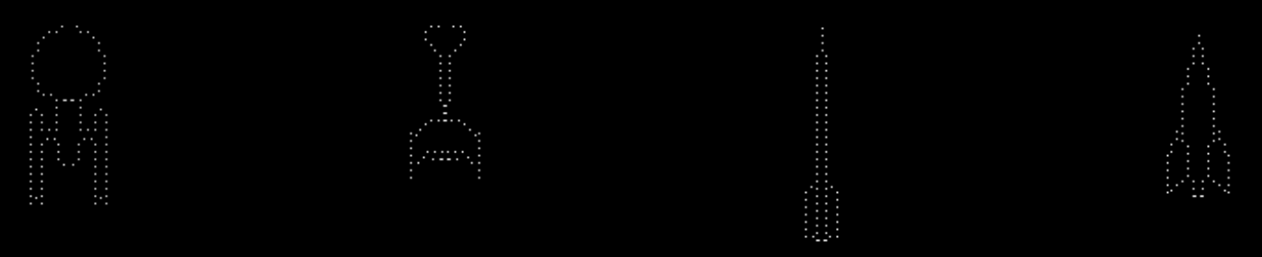

This gives us a nice opportunity to show a bit more of HACTRN, the debugger that is also the command line. Press F1 to interrupt the program, and then:

* Type <esc>Ctrl-K to load its symbol table(!)
* Type :lists to print out all the symbols
* Type nsuns/=1 to inspect the ‘number of suns’ symbol and change it to 1
* Type nships/=2 to change to a two-player games
* <esc>P proceeds with the program execution

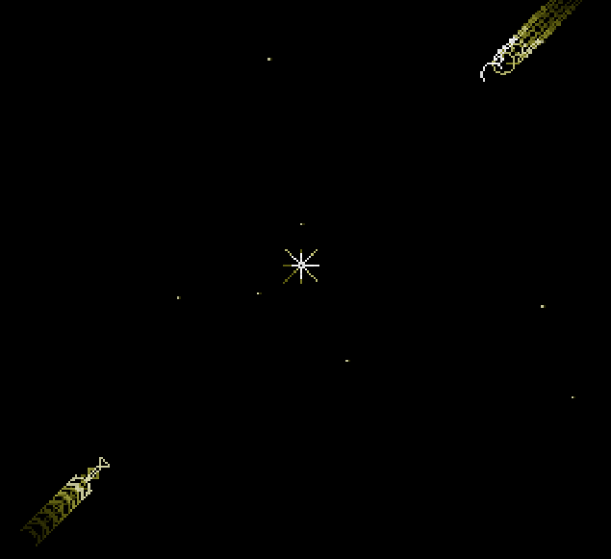Wait a bit, and once the current players perish and a new game commences, you’ll see the single sun with two spaceships as it was in the earlier PDP-1 version.

From which we draw the general conclusion that hackers do not really need a Settings menu if the a debugger is the command line.

Hit F1 to halt Spacewar, and :kill to remove its job.

The problem at the AI Lab, of course, was that there was only one type340 display, and it stood next to the PDP-10. Not next to a student’s Knight TV terminal. Therefore, a TV War game was also written. Type :tvwar to start it.

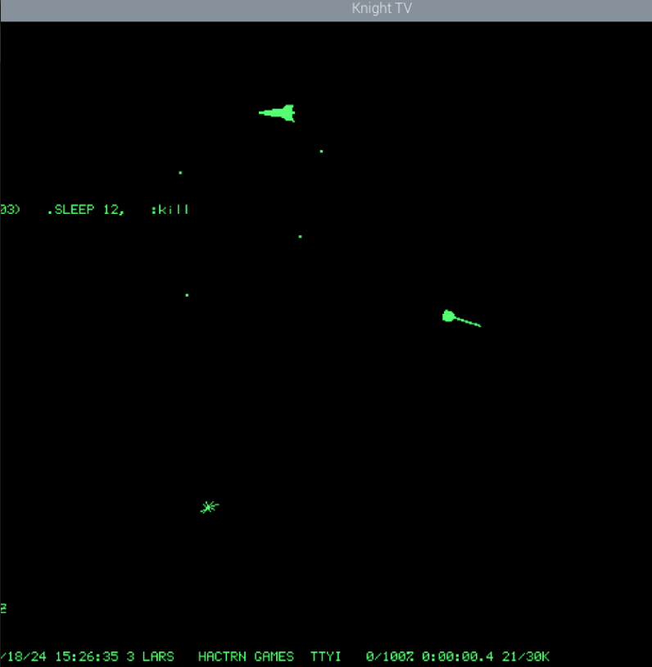

Player 1 controls his spaceship with Z,X,C for rotation, V for acceleration, and <space> to fire torpedoes. Player 2 uses [,],\, P and ;. But note: use capital letters.

There’s also Dazzle Dart, another very early video game to play. Alas, you really do need 4 players, each with a USB joystick. :games;dazdrt

## Adding a VT-52 terminal session, some Lisp therapy

Not everyone used a Knight TV terminal. Regular serial terminals were around as well (the Datapoint 3300, pdp dp3300, for instance). But users would log in from around the world over ARPANET. Let’s use an industry-standard DEC VT-52 terminal. Type pdp vt52 on the linux command line, at the top of PDP View, and let us use that to run Eliza, the very early AI therapist written in Lisp. Press F11 to make the VT-52 full-screen.

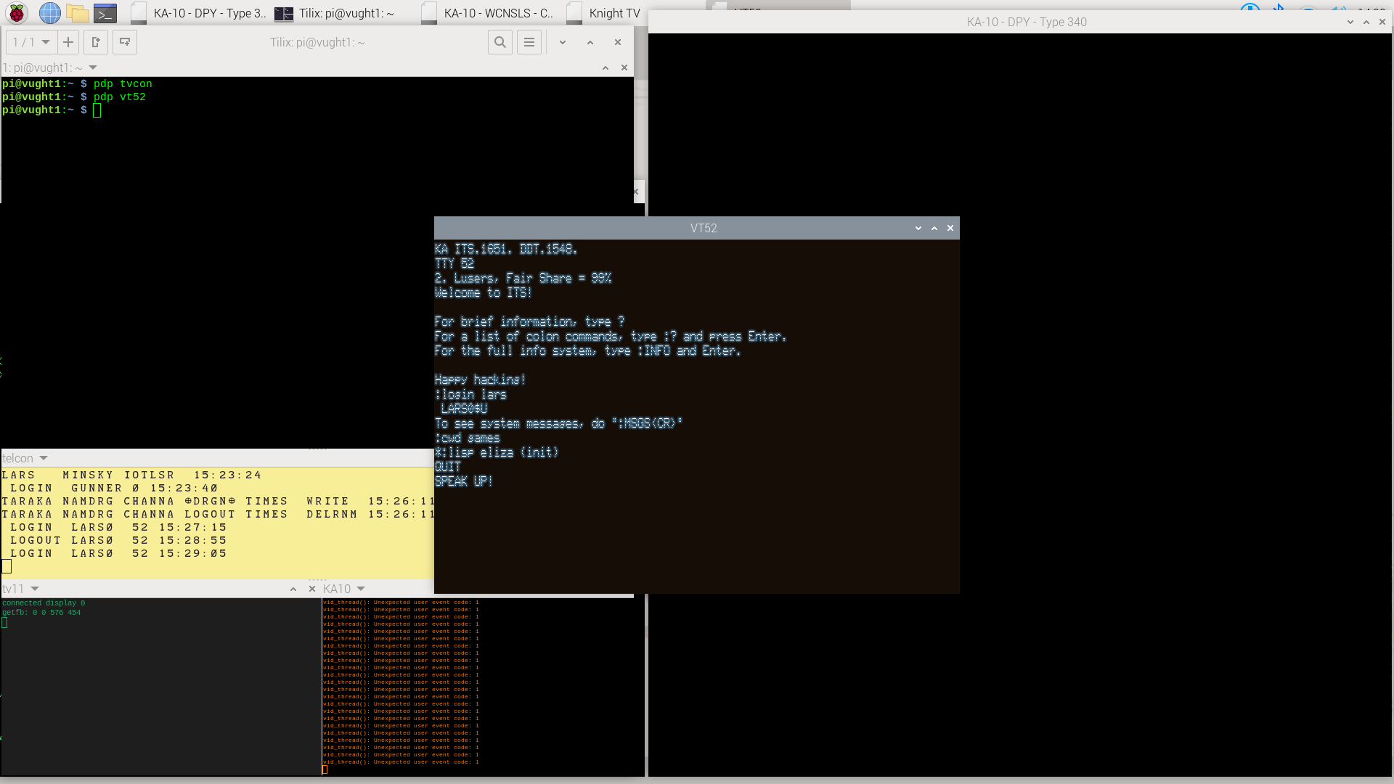

In the VT-52, press Ctrl-Z, type :login lars to log in, :cwd games and then :lisp eliza (init) . Now tell Eliza what is bothering you, and end your sorrows with a double return. You need a bit of experimentation in how you formulate your issues, but many have profited from Eliza once they did.

Press Ctrl-Z, and type :kill to leave Eliza behind. Ctrl-L to clear the screen perhaps, then :cwd lars to get back to Lars’s home directory again. Then, :emacs munch lisp will let you edit a simple ASCII-art version of munching squares. Emacs, of course, was born on ITS and thus is the preferred editor. You might want to try Teco, the other editor, to find out why.

Google on emacs keystrokes, but for now, CTRL-V does a page down – where you see that munching-squares will start the program. Ctrl-X Ctrl-C brings you back to HACTRN.

Then, do

* l Ctrl-K (lower-case l, this is the altmode equivalent of Turistish :lisp)
* answer n to the Alloc? Question
* (load “munch lisp”)
* (munching-squares)

This version of munching squares left an audience of ITS veterans distinctly unimpressed, when we did this demonstration recently. Which was fair enough, it was just to show lisp and the VT-52. So, press Ctrl-Z, :kill, :munch and watch a much more beautiful munching squares on the type340. Ctrl-Z, then :kill once you have enough. Here, too, you’ll find the source code in the same directory if you want to play with it.

To graciously leave ITS from this terminal, type :logout . Then, to virtually walk away from your VT-52, type Ctrl-], then quit. Just to demonstrate that we used a telnet connection to hook up the VT-52 with ITS. Close the VT-52 window.

## Multiple jobs

Select the Knight TV terminal window again, and perhaps press Ctrl-L to clear the screen.

Type :peek to run the ITS system monitor utility, the equivalent of top in Linux. Press ? to get an overview of its display pages. But more interestingly, press Ctrl-Y to let Peek use the type340; and then type p to proceed- meaning, let Peek run on the type340 but proceed with other jobs on the Knight TV terminal itself.

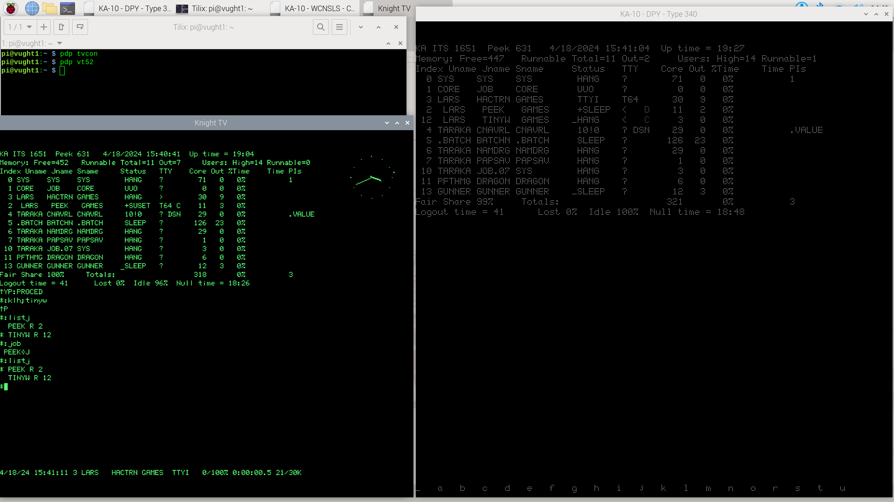

To demonstrate the multi-tasking from here, type

:klh;tinyw

and note how a small analog clock appears on the Knight TV. Press Ctrl-F to see that TinyWatch keeps running in the background as well, whilst you continue in HACTRN.

Enter

:emacs test to just start up one more job, and type Ctrl-X Ctrl-C to leave it in the background, too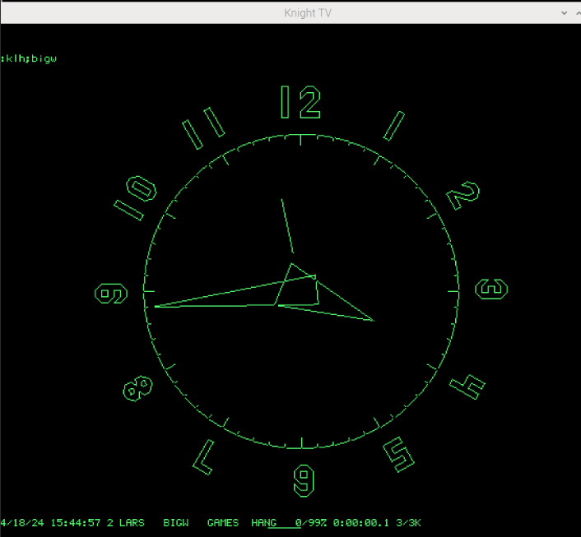.

You now have three jobs, and you can see them with :listj

Note that only one of the jobs has a * in front of it. This is considered the current job, you can rotate through the list of jobs with :job and then use :contin to continue it. Or just type :contin emacs.

Of course, you should look up the altmode keystrokes at some point to migrate from Luser (or perhaps, Turist) to hacker status.

Clean up all the jobs with a repeated :kill command, and to leave this Knight TV terminal in a decorative state, do :klh;bigw .

## The Ultimate 1970s AI demo: SHRDLU

It is very much worth googling for more background information on Shrdlu – this AI, living in a simple 3D world of a table full of blocks, boxes and pyramids has a ‘real’ understanding of its world, and its English language parser makes it accept surprisingly complex commands, and respond in a manner that shows actual insight into its little world.

Start up a second Knight TV terminal (by entering pdp tvcon on the Linux console):

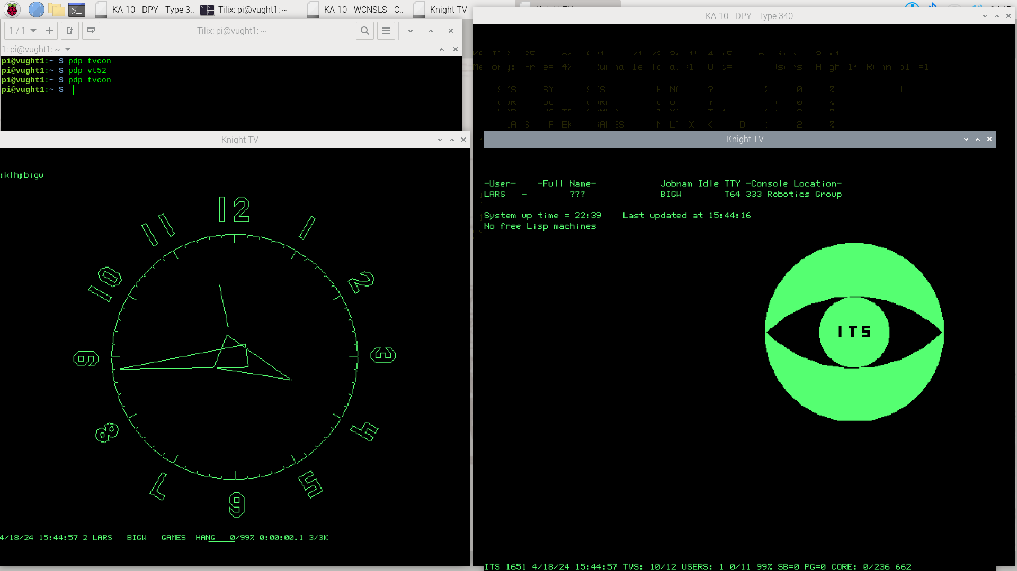

Again, log in to ITS (F1, :login turist) and go to the Shrdlu directory (:cwd shrdlu). Then, run the demo with :twdemo and start it off by typing Ctrl-Q *in the Knight TV terminal window*. Move the window aside so you have the type 340 window in full view again:

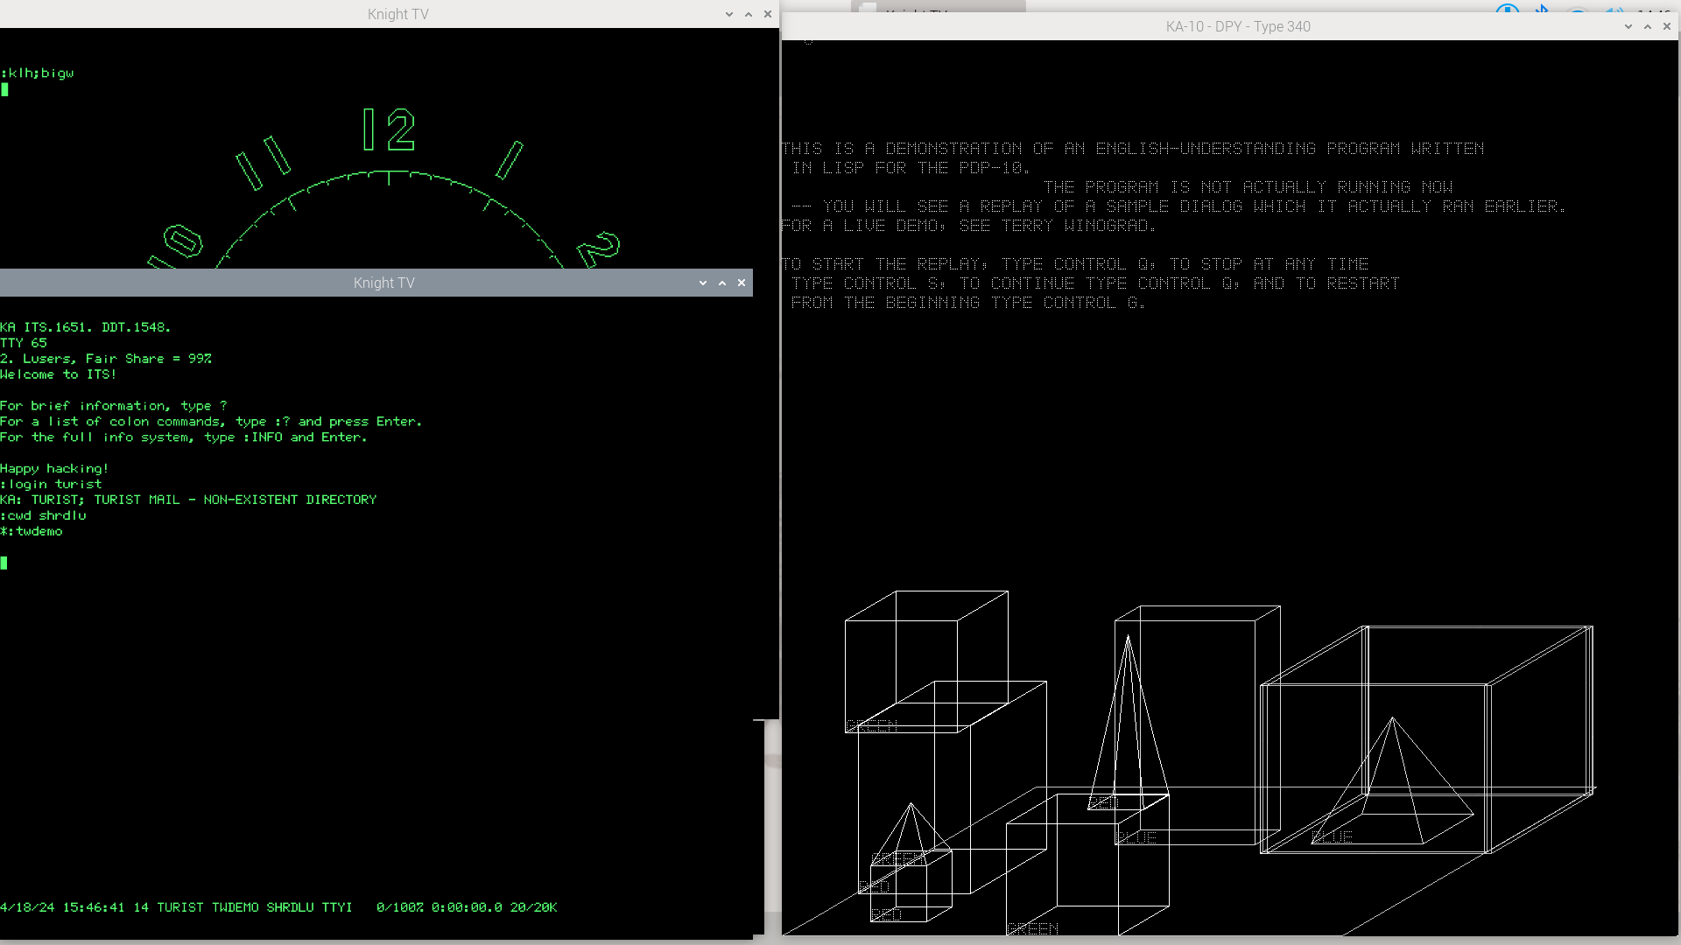

At some point, use F1 and :kill to terminate the demo. Sadly, the original *interactive* Shrdlu has not been recovered. We have only the scripted demo. Some Googling will tell you the story, and why it is not likely the full version ever will be brought back…

## Headless: remote Knight TV sessions

So far, we have demonstrated simulated terminals on the Pi’s HDMI monitor. But it will often be more convenient to run a terminal from your laptop, seated in a comfortable recliner chair. The PDP-10, after all, is a mainframe-class computer; terminals can be anywhere.

Moving the terminal simulator programs over to your Linux laptop/desktop:

* Transfer the file /opt/pidp10/bin/binaries-for-X86-64.tar.gz to your Linux laptop or desktop, and untar.
* Similarly, transfer the text files /opt/pidp10/bin/imlac.simh and /opt/pidp10/bin/ssv22.iml to your remote machine. They are needed by the Imlac simulator, of which we will need a remote instance to play Maze War.
* You might also copy /opt/pidp10/bin/pdp.sh over, and edit it to seek connections to the PiDP-10 instead of localhost.
* We do not *yet* have Windows binaries.

Alternative: compile on the Linux laptop/desktop from source:

* The VT-05/52 and Datapoint 3300 are easily built from github: <https://github.com/aap/vt05>
* The (imh) Imlac simulator can be built from here: <https://github.com/open-simh/simh>

Connecting to the PiDP-10:

Assuming your PiDP-10 is named pidp10, you can run ./tvcon -2BS pidp10.local to get a Knight TV on your remote machine. Similary, ./vt52 -B telnet pidp10.local 10018 for a VT-52, and so on.

Pressing F11 will make the terminal simulators use full-screen mode.

For the Imlac simulator, also replace the reference to localhost with pidp10.local (or whatever name you gave your PiDP-10) in the imlac.simh file.

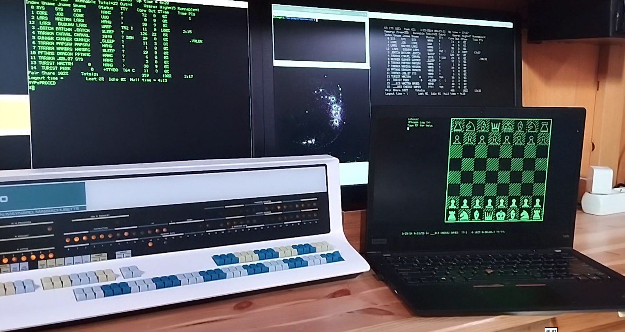

Above: a Knight TV’d laptop running MacHack VI chess on the PiDP-10 (run :games;ocm , and enter ps to let it play against itself). If you prefer, another chess version will use the type340 to display the board. Run :games;c , and type FANCYTAB2<enter>

## Multi-Player Maze War

Maze War might be the first 3D FPS game. Assuming you have prepared the Imlac simulator on a second Linux machine as per the above section, here are the steps.

On the PiDP-10 itself, start one Imlac simulator by running pdp imlac on the Linux command line. And on the Linux laptop/desktop, start another Imlac with ./imlac ./imlac.simh , and make sure you have edited the imlac.simh config file to replace the reference to localhost to pidp10.local – or whatever you chose for your PiDP-10’s network name.

Type Ctrl-Z, and :login turist (on the laptop) and :login lars (on the PiDP-10 imlac window) to get into ITS. To tell ITS that you are on an Imlac, type :tctyp oimlac , and on both machines, go to the games directory with :cwd games, and run :maze c (the C indicates you want Cheat mode).

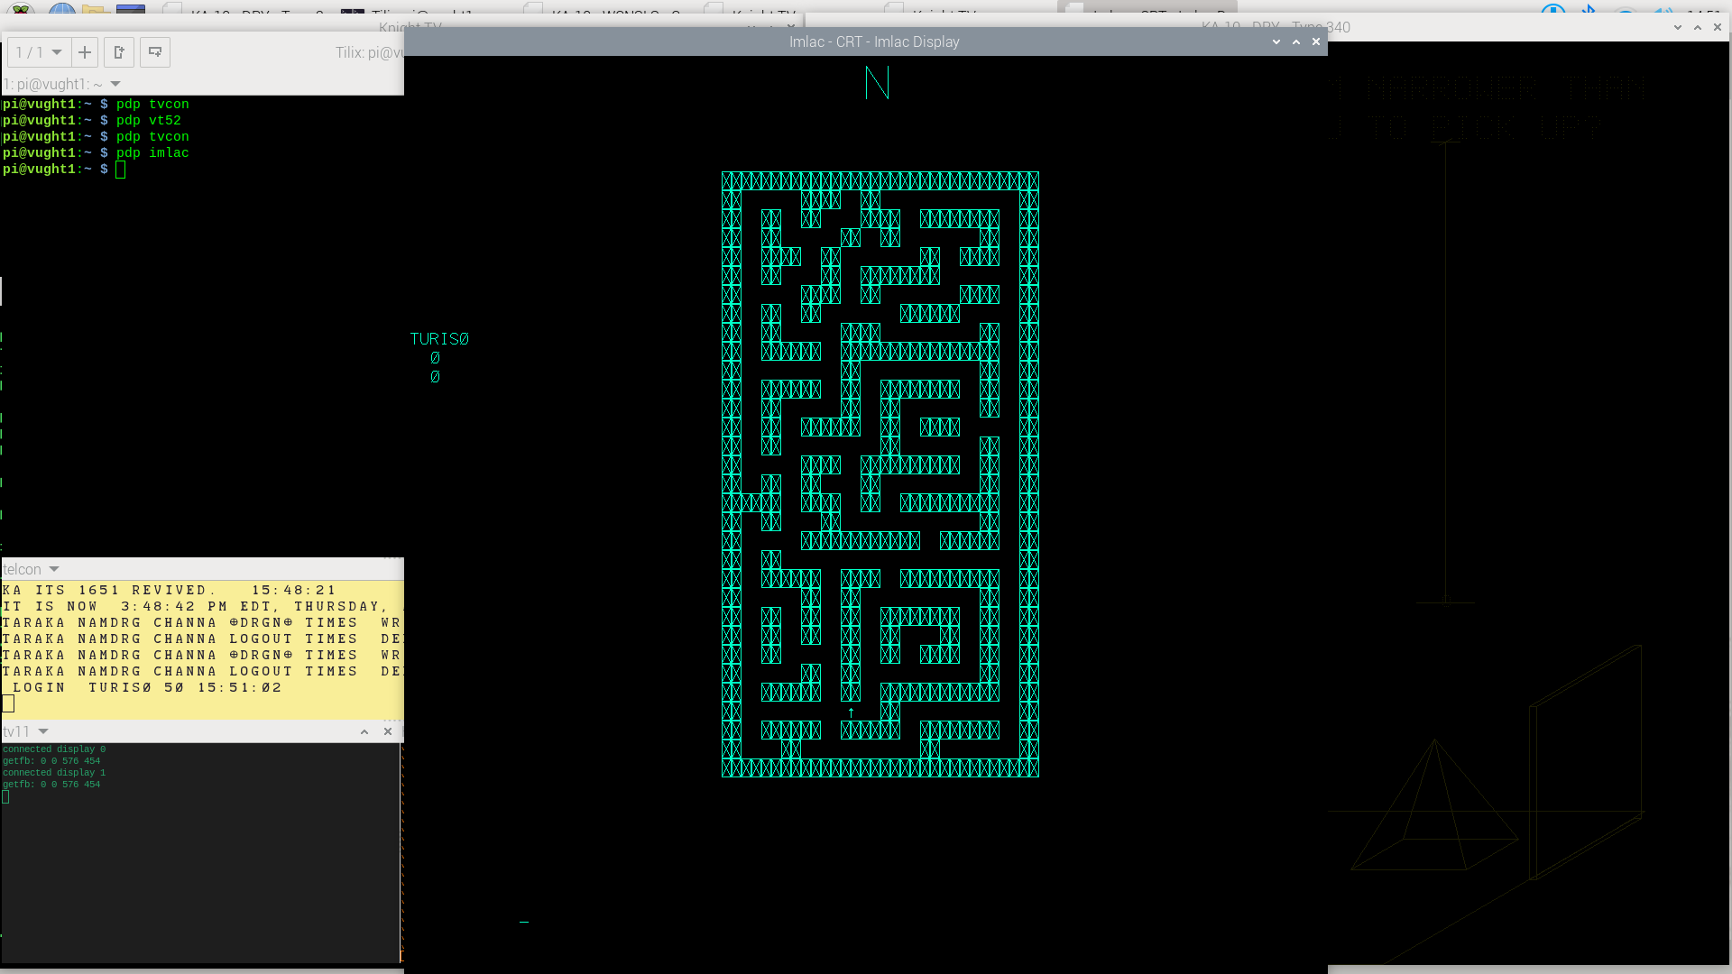

The Tab key will show you the maze with your position in it, the cursor keys let you move, and <esc> or <space> lets you shoot at your opponent when you encounter him.

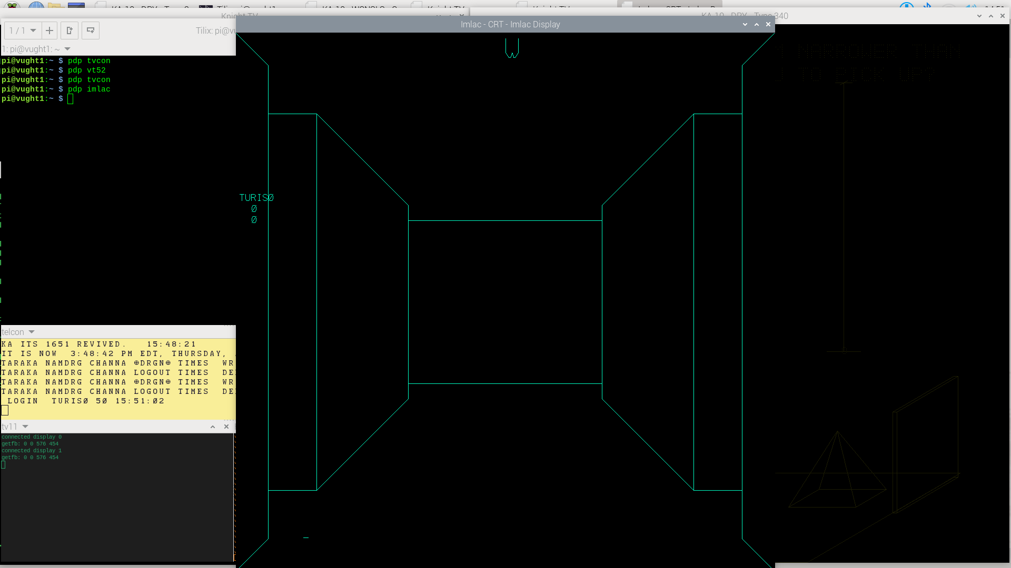

Once you are done, it is generally polite to clean up before you leave your Imlac terminal:

Ctrl-Z

:kill

:logout

- and then you can just close the Imlac simulator.

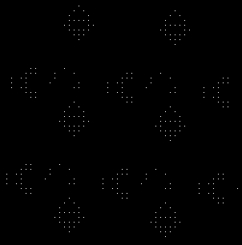

## Gosper’s Game of Life: the original

If you know your computer history, Life will need no introduction. The author of the PDP-10 Game of Life was Mike Speciner; and Bill Gosper (RWG)’s famous experimentation files were also recovered. This is where the Glider and other interesting patterns were first discovered. Worth Googling.

:games;mlife (to run it, the type340 will be the display, your current Knight TV the console)

Then, type (in the Knight TV window, where Mlife shows an underscore waiting for input):

I RWG;LIFE DEMO (caveat: you have to type uppercase input)

Hit (upper-case) R repeatedly to go through all the patterns in Gospers saved workbook, and hit space repeatedly to let the life evolution step through generations.

To see the source code:

:emacs rwg;mlife

And, as we get to the end of the walkthrough, a side step: it can be useful to see a bit more of the PiDP-10 simulator setup. If you ran the install script to also download the ITS source code (you can rerun the script to add the sources if you want), look in /opt/pidp10/src/its/src/rwg . This is the input for the reconstructed ITS disk image, but it is also handy to know all files are available for review and just spelunking around in Linux.

## Shutting down gracefully

You would normally type this on the Teletype console, but it works on any terminal. If the Teletype does not respond, type a Ctrl-Z to call ITS again. Then, to bring down ITS in an orderly manner, type:

:lock

5down

y

Ctrl-C

If there are no users still logged in, the shutdown will commence immediately. If there are any users still logged in, or some of their jobs still running, you’d have to wait 5 minutes. So it makes sense to :kill and :logout properly.

Generally, nothing bad occurs after a disorderly shutdown (if you do not wait for the five minutes). But trouble can occur. If it does, run the PiDP-10 install script to copy back a fresh set of ITS disk images.

One more thing...

## Bubble Universe - Democoding on the Color Scope

DEC delivered a color scope – although smaller, effectively a color version of the type340 – to the AI Lab. Only two of these were ever made, but it is a nice target for writing graphics demos. At the time of writing this manual, we’re not sure whether we should enable the ‘Cscope’ display window at startup or not. So if you do not see a smaller-sized ‘color scope’ window, you can enable it by editing the ITS boot script file. Which, in fact, is useful to know about anyway.

The boot scripts for PiDP-10s are named boot.pidp, and if you run a Naked Pi (no PiDP-10 hardware attached), the boot.pi scripts are used. So if you do not see the Cscope window just yet, simply edit /opt/pidp10/systems/its/boot.pidp (or .pi) to enable the Cscope window by (un)commenting out the highlighted line with a semicolon. You’ll then want to uncomment the line directly above, which makes sure your spacewar USB controllers are still enabled. You’ll have to reboot for changes to take effect; the Cscope window will only appear once ITS is booted up.

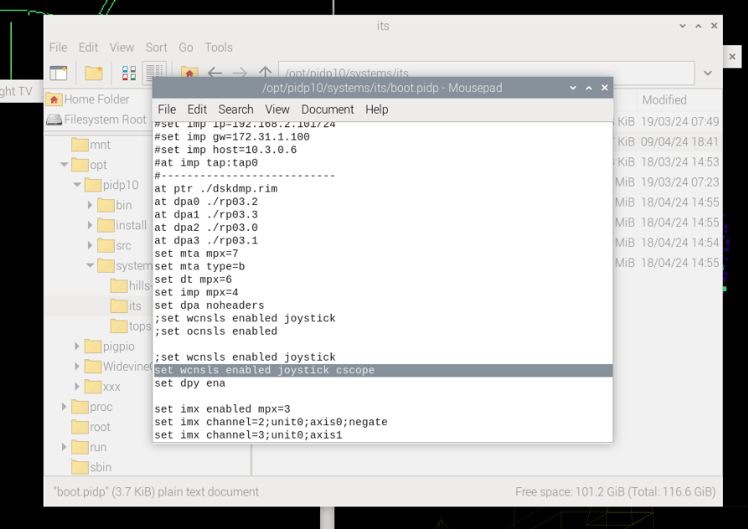

And note that similarly, the line below the highlighted one causes the type340 to appear or not. There are many more customisation options in the boot file, which is why we’d like to show it in this ‘walkthrough’.

Good – assuming you have the Cscope window on your display, there is a newly-written piece of democode to highlight the possibilities. Lars Brinkhoff wrote it in PDP-10 assembler, in late 2023, based off a thread here: <https://retrocomputingforum.com/t/the-marvellous-bubble-universe-graphical-animation/3651>

Go back to one of the Knight TV terminals that you still have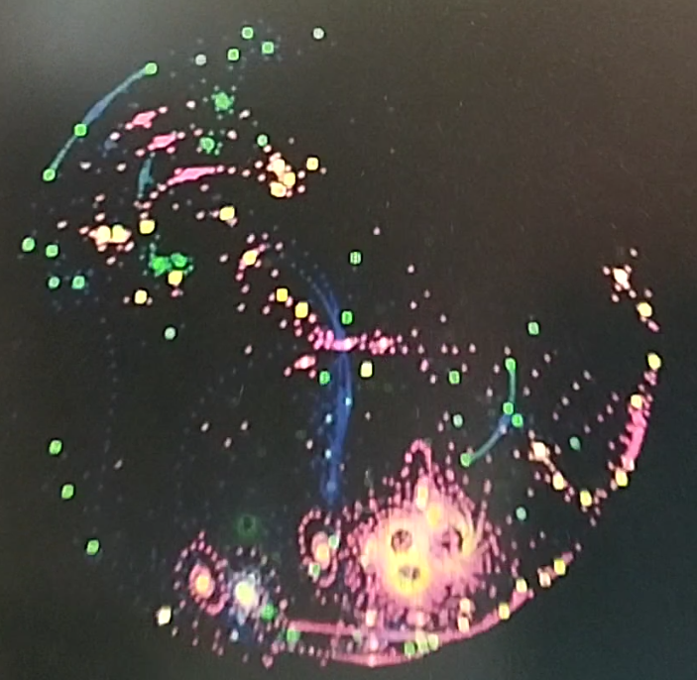 open. Type F1 and :kill in case anything is still running on it, and do :cwd lars to go to his directory. Then:

:emacs bubunv > (to open the latest version – ITS does versioning! - of the source code)

Hit Ctrl-V to page through the 6 screens of PDP-10 assembly, Ctrl-X Ctrl-C to leave emacs. Use the Midas assembler to assemble the source into a binary:

:midas bubunv (bubunv without extension will let ITS pick the latest source version)

Hit Ctrl-F, and you will now see a BUNUNV BIN binary. Create a new job, load the binary in it and let it run:

* bubunv<esc>j
* <esc>l bubunv bin
* <esc>g

And again, stop with F1 and :kill .

# A first look at TOPS-10

This is a shorthand version, a more readable version will come soon.

sched

enter date/time

startup option: quick

... some errors follow

LOGIN 1,2

pwd is FAILSA

logged in...

DIR

SET TTY NO BLANKS

nicer, less empty lines

Open a second terminal, from the Linux command line:

telnet pidp10a.local 2020

and once in, LOGIN 101,101

make new user with react:

R REACT

R

(reads user database)

T

(lists all users)

exit with crtlC

KJOB

kills your job and logs you out. Choose F for fast

KJOB/F is also good...

LOGIN 101,101

(no pwd needed)

TYPE HELLO.F4

COMPILE HELLO.F4

LOAD HELLO

or load hello.rel

START, to start the current core image. RUN would load and run a file from disk

SAVE HELLO

OSAVE HELLO (the high file HGH version, difference is whether zeros are compressed)

You can create low and high files

r file (system program)

RUN file (load from current dsk)

R TECO

ERHELLO.F4$

DIR[1,1] shows MFD

DIR [1,4] then shows another dir

COMPILE HELLO.MAC would assemble, LOAD HELLO.REL, results in HELLO.SAV

SAV file would be smaller but would not have a de,and page if you have that in your system.

EXECUTE HELLO would do everything needed and then run

DIR DSKB0[1,1]

DIR DSKB2[1,1]

R PIP

newfile=oldfile

If you have H.MAC

skip COMPILE, just do LOAD H, that will automagically do the compile also

E 6451 to examine, similar for d

DDT......

DEBUG loads eerything, DDT and your program and symbol table

R OPSER (jobs control program)

DETACH logs you out but you're still i the background

ATTACH 1 [101,101] brings you right back.

SYSSTAT will show you your job number even if not logged in

# Front panel operations – a primer

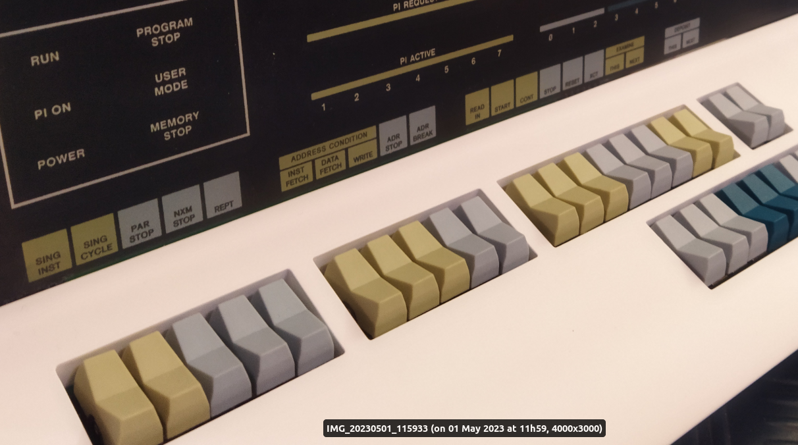

If you are used to the front panels of simpler computers, you’ll be in for a pleasant surprise with the PDP-10’s. It contains some advanced debugging features. Below is a copy of the relevant section of the PiDP-10 wiki ([https://github.com/obsolescence/pidp10/wiki/PiDP%E2%80%9010-testing](https://github.com/obsolescence/pidp10/wiki/PiDP‐10-testing)) to give an overview.

The nice thing is that this overview also is a first introduction of the simh command line. It is a very nice tool for writing and debugging short PDP-10 programs, as you’ll see during the explanation of the front panel.

Lars Brinkhoff made a very effective Youtube movie about the PDP-10 front panel’s operation. See it [here (link)](https://www.youtube.com/watch?v=XFmEHmySNT0).

## The basics

It’s recommended to play with the front panel after (re)booting the system into Hill’s Blinky (by not setting any of the data switches, pdpcontrol stop, followed by pdpcontrol start. If you want to leave whatever is on the data switches, just do pdpcontrol start 0 to let the PiDP-10 ignore the actual value on the data switches, and boot Hill’s Blinky regardless.

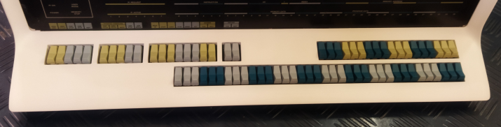

**Data switches**: the bottom row of 36 switches. If front panels are new to you, these can be used to toggle in the binary value to store into some memory location[4].

**Address switches**: the row of 18 switches on the top right; they are use to form an address. Either an address you want to deposit the data switch contents in to, or the address of a word in memory you would like to examine.

**Control switches**: the 20 switches on the top left. We will go into them now.

So, it follows that a simple use of the front panel is to set a value on the data switches, set an address on the address switches. Press STOP to halt the machine, press EXAMINE THIS to see what is currently stored in the selected address, and press DEPOSIT THIS to replace that value with the value set on the data switches. Press EXAMINE THIS again to see that, indeed, the value from the data switches is stored in memory.

If you enter a series of words into memory (a little program for instance), it would be annoying to have to set the address switches for every new word. Therefore, you can use EXAMINE NEXT and DEPOSIT NEXT to just walk through memory word-by-word, either to look at what is in memory, or to enter new values from the data switches.

See this page on the PiDP-10 wiki to practie a bit with Examine & Deposit: (link)

## Program Control

After inspecting and changing data in memory, the front panel’s practical use is of course on running and stopping programs.

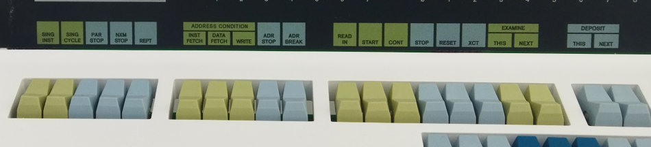

The section (please follow this [link](https://github.com/obsolescence/pidp10/wiki/PiDP‐10-tests%3A-program-control)) of the Wiki contains a practical exercise: how to enter a little program in the simh command line, how to start, stop, restart or continue the running program’s execution; and how to single-step through its instructions as it runs.

Unsurprisingly, this is done with the START, STOP, CONT switches. Setting SING INST will single step, every time you press CONT it will only execute the next instruction and stop again. But if you set REPT, and keep depressing CONT, it will just slowly step through the instructions so you can follow along.

The XCT switch has a special function: it executes the data on the data switches straight away as an instruction, without needing any memory address to store the instruction in.

# Networking on the PDP-10

The PiDP-10 comes with a working Chaosnet installed, so that the Pi and the PDP-10 can talk to each other. Two immediate uses present themselves:

## File exchange between ITS and Linux

The utility program mlftp will do this, connect from Linux to ITS over Chaosnet, and read/write files. A minimal example:

/opt/pidp10/bin/mlftp -w its test ~/test

...will store the file in the .TEMP. directory of ITS. Run mlftp without arguments to see its options.

Or:

mlftp -w its -- "-READ- -THIS- GAMES;" read-this.txt

...to show an example with full ITS filenames. Note that the semicolon demarks the directory.

## Terminal sessions over Chaosnet: supdup

Supdup was a groundbreaking virtual terminal; it is worth reading up on it online, because there is much more than meets the eye. But the simplest example:

/opt/pidp10/bin/supdup its

Note that *this* supdup is a Linux version of supdup, it is not a simulator. There is also a supdup in ITS itself, which will allow you to visit other ITS systems. :supdup will get it running. It is a very elegant way to connect to other systems over the global Chaosnet, but setting up networking beyond the host Pi is another section.

## Chaosnet

Chaosnet was MIT’s a LAN technology from 1975. The name refers both to networking hardware and to a protocol. You can have Chaosnet-over-IP, but also Chaosnet-over-Unix-sockets, and much more.

The PiPD-10 starts a minimal Chaosnet connection between ITS and the host Pi in the ITS bootscript. It runs the external program cbridge, something you could do on the command line as well,

/opt/pidp10/bin/cbridge -c /opt/pidp10/bin/cbridge.conf

Cbridge can do much more, and cbridge.conf holds the key to everything. See <https://github.com/bictorv/chaosnet-bridge>

## Future Networking sections

(Work in progress, hints for the moment are:)

* SYSNET; TELNET 752 - TELNET client for TCP
* SYSNET; CHTN 15 - TELNET client for Chaosnet

ITS can be part of the global HECnet network, use TCP/IP, and other modern niceties. It can also be part of a re-created ARPANET. The IMP device is part of the simulation. Future updates of the manual will give much more detail (as we explore the practical setups).

# Further reading

https://github.com/obsolescence/pidp10/wiki/PiDP%E2%80%9010-testing

https://its.victor.se/wiki/start

https://chaosnet.net/

The first thing you need is a simulated Teletype to plug in to the PDP-10’s console port. So you can communicate with it during the boot process. The PiDP-10 provides multiple ‘simulated Teletype’ programs, but in the end, they are all the same: a telnet connection to port 1025, which is where simh puts the console port.

We try to keep things as authentic as possible.

* So if you have the PiDP hardware plugged in to your Pi, simh runs /opt/pidp10/systems/its/bootscript.pidp, which is set up to do what a real PDP-10 does: wait for you to press the STOP switch to halt the system, and press the READ IN switch to read in the paper tape[5] and run it. That is when DSKDMP appears on your Teletype. And you need the Teletype to boot further from here, by typing “ITS<return><esc>G”. If you chose to boot ITS.
* If you do not have the PiDP front panel attached – you are running on a Naked Pi – then it is not bootscript.pidp that is run, it is bootscript.pi; and it skips anything to do with front panel switches. It just starts booting straight away.

When the PDP-10 is running, ‘screen’ is a very useful program to know about. Do ‘screen -ls’ to let it show you what virtual terminals are running. ‘screen -Dr pidp10’ will get you the simh virtual terminal, Ctrl-A d lets you leave the virtual terminal again. It’s good to google a bit on the many handy features of ‘screen’.

Next to ‘pidp10’ there will also be a ‘vt11’ virtual terminal if you have booted up ITS. Started by the bootscript for ITS, it is the separate simulator running the PDP-11 that handled Knight TV terminals. It has shared memory with the PDP-10 actually. Similarly, there is a virtual screen for the Chaosnet bridge that the bootscript has started.

1. If you do not like this inauthentic step, you can take it out of the ‘pdpcontrol.sh’ script that does this.
2. Unless you configure the bootscript so that the simulated PDP-10 serial port is actually a real Raspberry Pi serial port. These simh bootscripts are infinitely flexible.
3. If you have a real serial terminal, you can reconfigure the bootscript to not use telnet but an actual serial port.
4. But it is only one way in which they are used; programs can read the switch register to see which switches a user sets; ITS does this for the leftmost switch – setting it will drop you in the debugger. The source code of :GAMES;MINSKY and the PiDP-10 demo progam Hill’s Blinky give examples.
5. That is placed in the virtual reader, the boot script has done that for you already. But you could do it manually.